Coding Assignment – Associate Software Engineer

1. JAVA

A. Create an array with the values (1, 2, 3, 4, 5, 6, 7) and shuffle it.

import java.util.Random;

public class ShuffleArray {

public static void main(String[] args) {

int[] originalArray = {1, 2, 3, 4, 5, 6, 7};

int[] shuffledArray = originalArray.clone();

shuffleArray(shuffledArray);

for (int number : shuffledArray) {

System.out.print(number + " ");

}

}

public static void shuffleArray(int[] array) {

int n = array.length;

Random rand = new Random();

for (int i = n - 1; i > 0; i--) {

int j = rand.nextInt(i + 1);

int temp = array[i];

array[i] = array[j];

array[j] = temp;

}

}

}

B. Enter a Roman Number as input and convert it to an integer. (ex IX = 9)

import java.util.HashMap;

public class RomanToInteger {

public static void main(String[] args) {

HashMap<Character, Integer> romanToInteger = new HashMap<>();

romanToInteger.put('I', 1);

romanToInteger.put('V', 5);

romanToInteger.put('X', 10);

romanToInteger.put('L', 50);

romanToInteger.put('C', 100);

romanToInteger.put('D', 500);

romanToInteger.put('M', 1000);

String romanNumber = "IX"; // Change this to the Roman numeral you want to convert

int result = 0;

for (int i = 0; i < romanNumber.length(); i++) {

int current = romanToInteger.get(romanNumber.charAt(i));

int next = (i + 1 < romanNumber.length()) ? romanToInteger.get(romanNumber.charAt(i + 1)) : 0;

if (current < next) {

result -= current;

} else {

result += current;

}

}

System.out.println("Integer value of " + romanNumber + " is: " + result);

}

}

C. Check if the input is pangram or not. (Pangram is a sentence that contains all the alphabet from a-z)

public class PangramChecker {

public static void main(String[] args) {

String sentence = "The quick brown fox jumps over the lazy dog";

if (isPangram(sentence)) {

System.out.println("The sentence is a pangram.");

} else {

System.out.println("The sentence is not a pangram.");

}

}

public static boolean isPangram(String sentence) {

sentence = sentence.toLowerCase();

for (char c = 'a'; c <= 'z'; c++) {

if (sentence.indexOf(c) == -1) {

return false;

}

}

return true;

}

}

2 JavaScript

1. Take a sentence as an input and reverse every word in that sentence.

a. Example - This is a sunny day > shiT si a ynnus yad.

function reverseWords(sentence) {

const words = sentence.split(' ');

const reversedWords = words.map(word => {

return word.split('').reverse().join('');

});

const reversedSentence = reversedWords.join(' ');

return reversedSentence;

}

const inputSentence = "This is a sunny day";

const reversedSentence = reverseWords(inputSentence);

console.log("Reversed Sentence: " + reversedSentence);

1. Perform sorting of an array in descending order.

const numbers = [5, 2, 9, 1, 5, 6];

numbers.sort((a, b) => b - a);

console.log("Sorted Array in Descending Order: " + numbers.join(' '));

3. HTML

1. Create a basic calculator using HTML, CSS, and JavaScript with the functionality of add, subtract, multiply and divide. Use the following picture for reference.

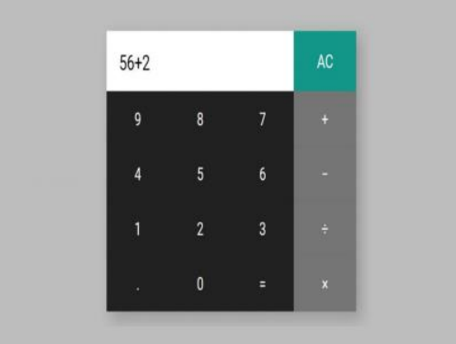

<!DOCTYPE html>

<html>

<head>

<title>Basic Calculator</title>

<style>

body {

font-family: Arial, sans-serif;

}

.calculator {

width: 300px;

margin: 0 auto;

padding: 20px;

border: 1px solid #ccc;

border-radius: 5px;

background-color: #f4f4f4;

}

input[type="text"] {

width: 100%;

padding: 10px;

margin-bottom: 10px;

}

button {

width: 48%;

padding: 10px;

font-size: 18px;

margin: 5px;

}

</style>

</head>

<body>

<div class="calculator">

<h2>Basic Calculator</h2>

<input type="text" id="display" readonly>

<div>

<button onclick="appendToDisplay('7')">7</button>

<button onclick="appendToDisplay('8')">8</button>

<button onclick="appendToDisplay('9')">9</button>

<button onclick="clearDisplay()">C</button>

</div>

<div>

<button onclick="appendToDisplay('4')">4</button>

<button onclick="appendToDisplay('5')">5</button>

<button onclick="appendToDisplay('6')">6</button>

<button onclick="appendToDisplay('+')">+</button>

</div>

<div>

<button onclick="appendToDisplay('1')">1</button>

<button onclick="appendToDisplay('2')">2</button>

<button onclick="appendToDisplay('3')">3</button>

<button onclick="appendToDisplay('-')">-</button>

</div>

<div>

<button onclick="appendToDisplay('0')">0</button>

<button onclick="appendToDisplay('')"></button>

<button onclick="appendToDisplay('/')">/</button>

<button onclick="calculateResult()">=</button>

</div>

</div>

<script>

function appendToDisplay(value) {

document.getElementById('display').value += value;

}

function clearDisplay() {

document.getElementById('display').value = '';

}

function calculateResult() {

const expression = document.getElementById('display').value;

try {

const result = eval(expression);

document.getElementById('display').value = result;

} catch (error) {

document.getElementById('display').value = 'Error';

}

}

</script>

</body>

</html>

1. Create a survey form with Fields; First Name, Last Name, Date of Birth, Country (dropdown), Gender (checkbox), Profession, email, and mobile number. All the input fields are necessary to submit the form. Create two buttons Submit and Reset. Reset will reset the form while clicking on submit, first, it will check all the fields and necessary validations and then a popup will appear displaying all the selected values with the label in front of it. On closing the popup, the form should reset all the values. Use the following for reference 3

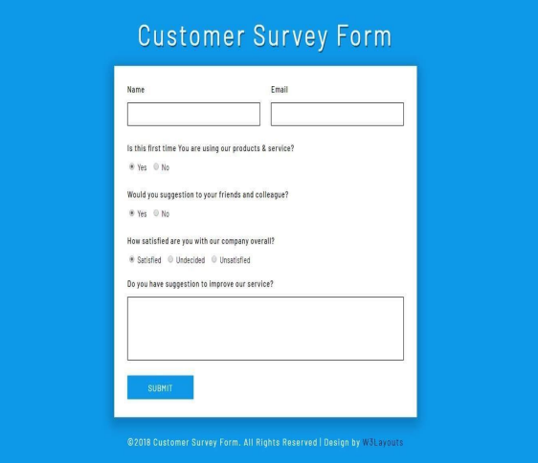

<!DOCTYPE html>

<html>

<head>

<title>Survey Form</title>

<style>

.popup {

display: none;

position: fixed;

top: 50%;

left: 50%;

transform: translate(-50%, -50%);

background-color: #fff;

padding: 20px;

border: 1px solid #ccc;

box-shadow: 0 2px 4px rgba(0, 0, 0, 0.2);

}

</style>

</head>

<body>

<form id="surveyForm">

<label for="firstName">First Name:</label>

<input type="text" id="firstName" required><br><br>

<label for="lastName">Last Name:</label>

<input type="text" id="lastName" required><br><br>

<label for="dob">Date of Birth:</label>

<input type="date" id="dob" required><br><br>

<label for="country">Country:</label>

<select id="country" required>

<option value="" disabled selected>Select your country</option>

<option value="USA">USA</option>

<option value="Canada">Canada</option>

<!-- Add more options as needed -->

</select><br><br>

<label>Gender:</label>

<input type="checkbox" id="male" name="gender" value="Male"> Male

<input type="checkbox" id="female" name="gender" value="Female"> Female<br><br>

<label for="profession">Profession:</label>

<input type="text" id="profession" required><br><br>

<label for="email">Email:</label>

<input type="email" id="email" required><br><br>

<label for="mobile">Mobile Number:</label>

<input type="tel" id="mobile" required><br><br>

<button type="button" onclick="submitForm()">Submit</button>

<button type="button" onclick="resetForm()">Reset</button>

</form>

<div id="popup" class="popup">

<h2>Survey Form Submission</h2>

<div id="popupContent"></div>

<button onclick="closePopup()">Close</button>

</div>

<script>

function submitForm() {

// Validate the form

if (document.getElementById('surveyForm').checkValidity()) {

// Get form data

const firstName = document.getElementById('firstName').value;

const lastName = document.getElementById('lastName').value;

const dob = document.getElementById('dob').value;

const country = document.getElementById('country').value;

const genderElements = document.getElementsByName('gender');

const gender = Array.from(genderElements)

.filter(element => element.checked)

.map(element => element.value)

.join(', ');

const profession = document.getElementById('profession').value;

const email = document.getElementById('email').value;

const mobile = document.getElementById('mobile').value;

// Display data in a popup

const popupContent = `

<p><strong>First Name:</strong> ${firstName}</p>

<p><strong>Last Name:</strong> ${lastName}</p>

<p><strong>Date of Birth:</strong> ${dob}</p>

<p><strong>Country:</strong> ${country}</p>

<p><strong>Gender:</strong> ${gender}</p>

<p><strong>Profession:</strong> ${profession}</p>

<p><strong>Email:</strong> ${email}</p>

<p><strong>Mobile Number:</strong> ${mobile}</p>

`;

document.getElementById('popupContent').innerHTML = popupContent;

// Display the popup

document.getElementById('popup').style.display = 'block';

// Reset the form

document.getElementById('surveyForm').reset();

}

}

function resetForm() {

document.getElementById('surveyForm').reset();

}

function closePopup() {

document.getElementById('popup').style.display = 'none';

}

</script>

</body>

</html>